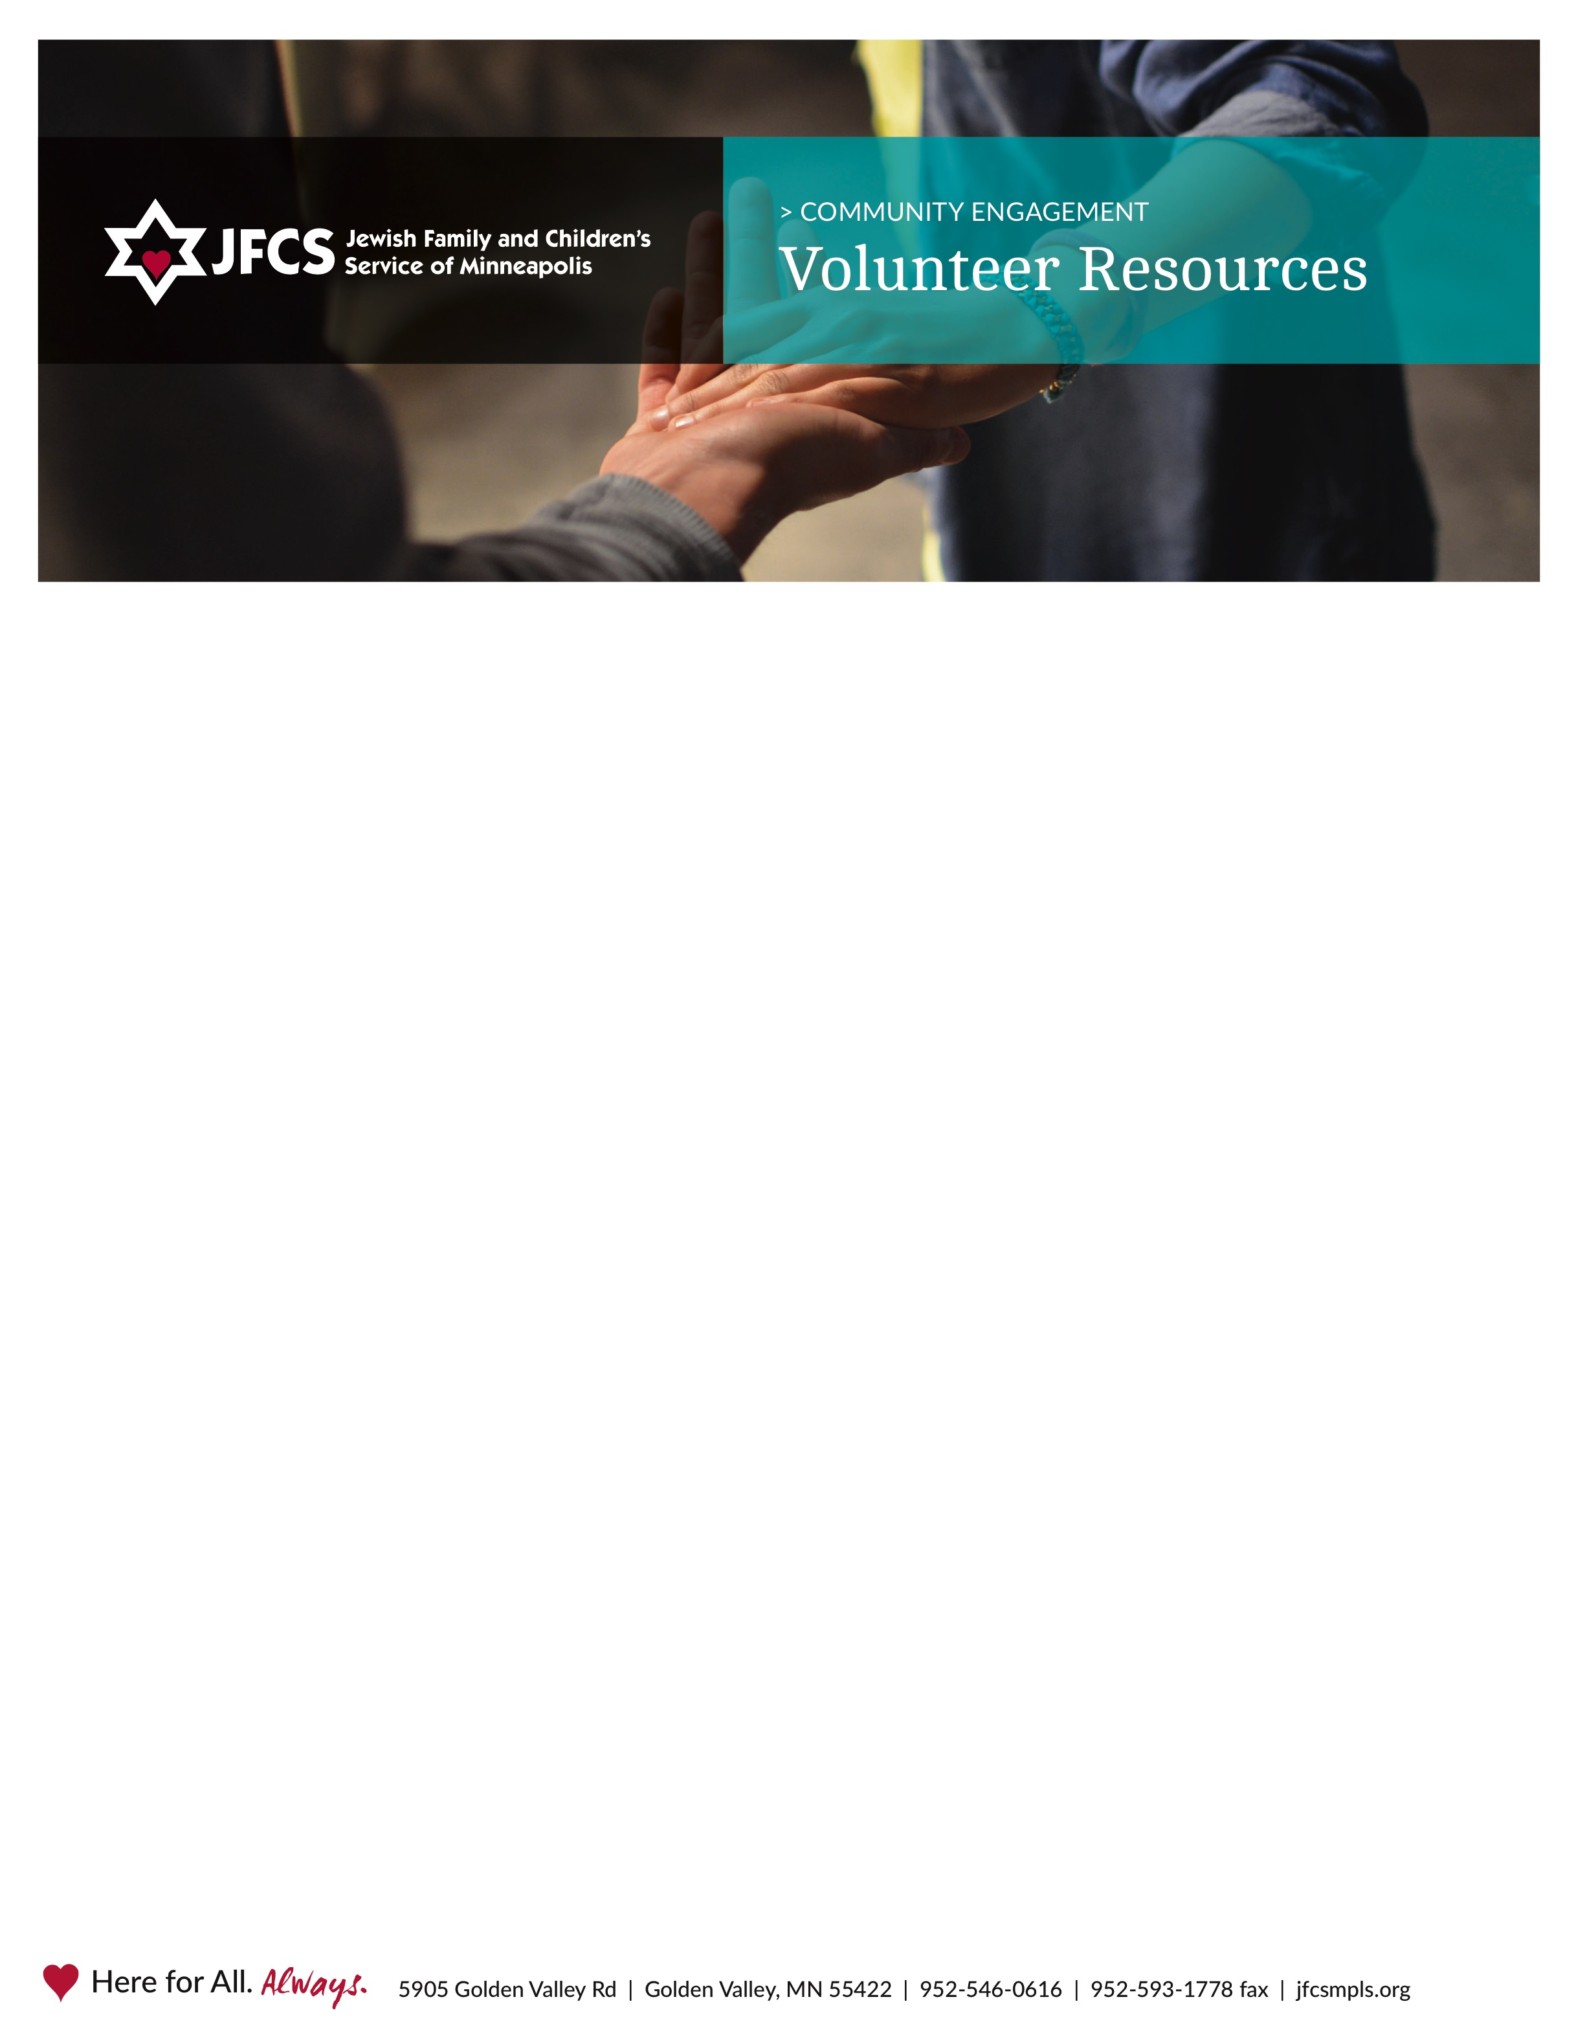

**Jewish Youth Mentoring Program**

***Volunteer Mentor Job Description***

**Purpose:** To develop a special one-to one, consistent relationship with a child by sharing interests, hobbies and activities. To facilitate the child’s development by providing a positive Jewish role model for the child to identify with.

**Duties:** May include any or all listed below:

* Meeting with mentee per plan—usually twice a month.
* Submit brief check-in form online after each meeting with mentee.
* Attend update meetings with the family and program staff when needed.

**Expectations:** All volunteers are expected to stay within the boundaries of their job, maintain client confidentiality, and abide by the policies stated in the volunteer handbook.

**Time Required:** Approximately 2-4 hours per month interacting with mentee, plus contact with parent(s) and program staff in between. Initial commitment of one year required.

**Qualifications:** A fun, mature, well-adjusted teen (age 16+) or adult who takes an active interest in the welfare of children. Must be able to communicate well and establish a good rapport with youth. A non-judgmental attitude is imperative.

**Training:** An individual orientation is provided to all new volunteers. Support and ongoing training from professional program staff.

**Benefits:** This is a special opportunity to share your interests and have fun with a child on a continuing basis. More important is the opportunity to have a significant, positive effect on the child through the friendship and guidance you can provide.

**Staff Contact:** Dori Gelfman, Jewish Youth Mentoring Program Coordinator [dgelfman@jfcsmpls.org](mailto:dgelfman@jfcsmpls.org) or 952-542-4835

*r. 11.3.22*